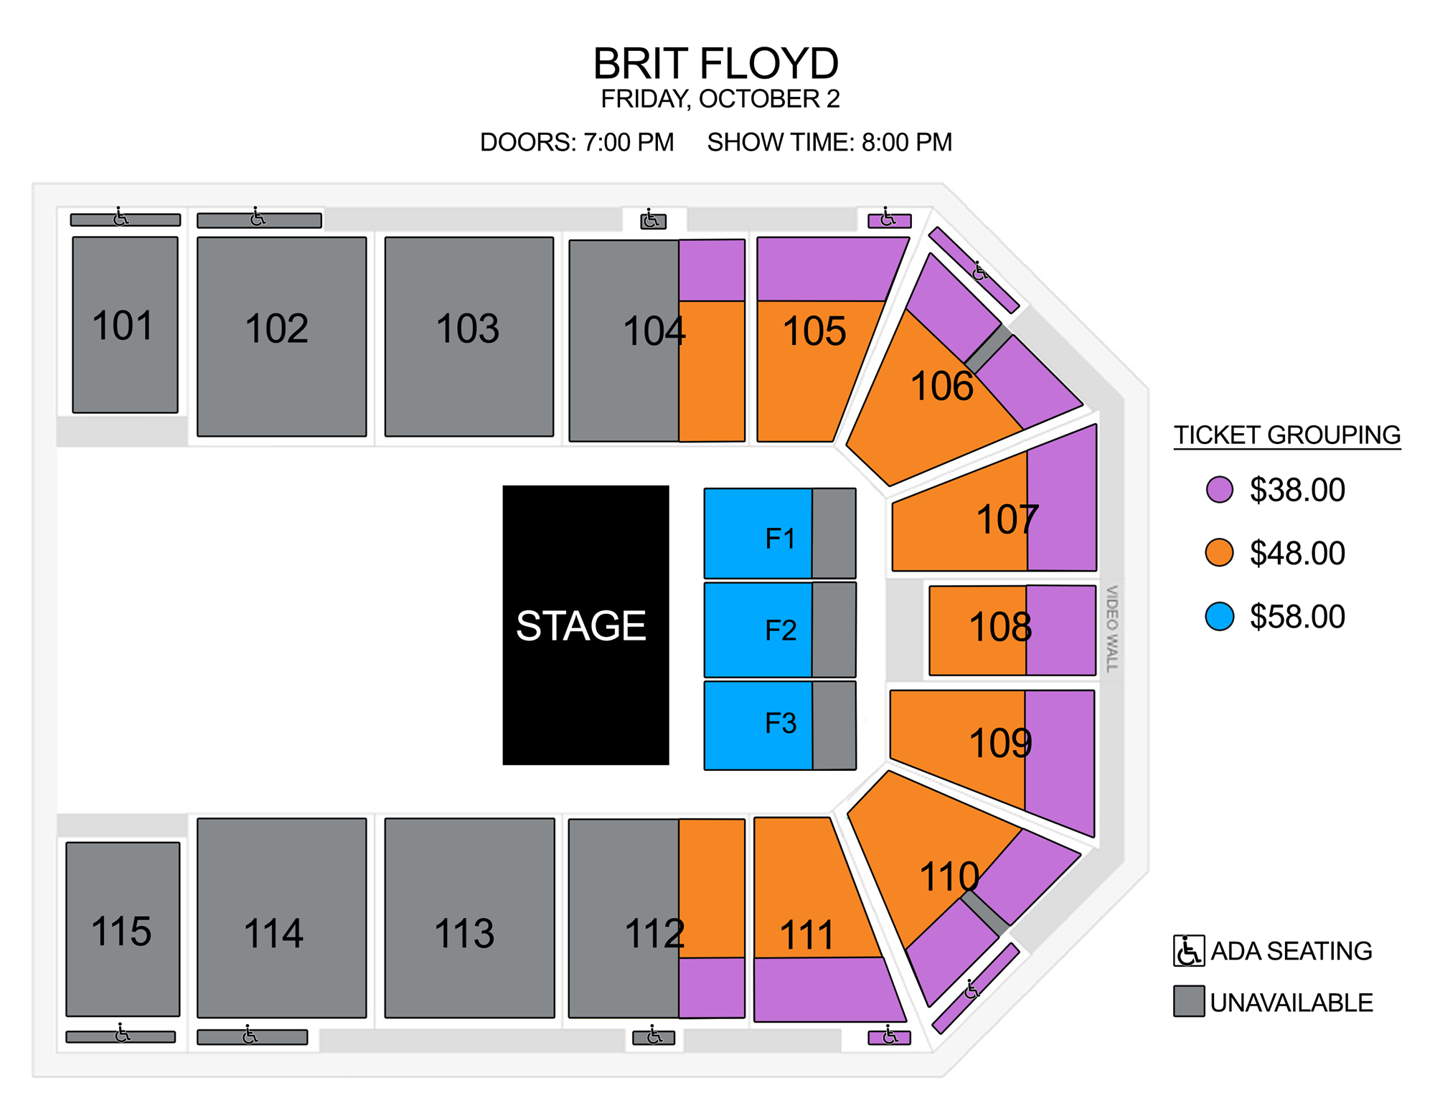
HEARTLAND CREDIT UNION ARENA
CUT OFF: 09/25

CLUB:
$34.00
$43.00
$52.00

