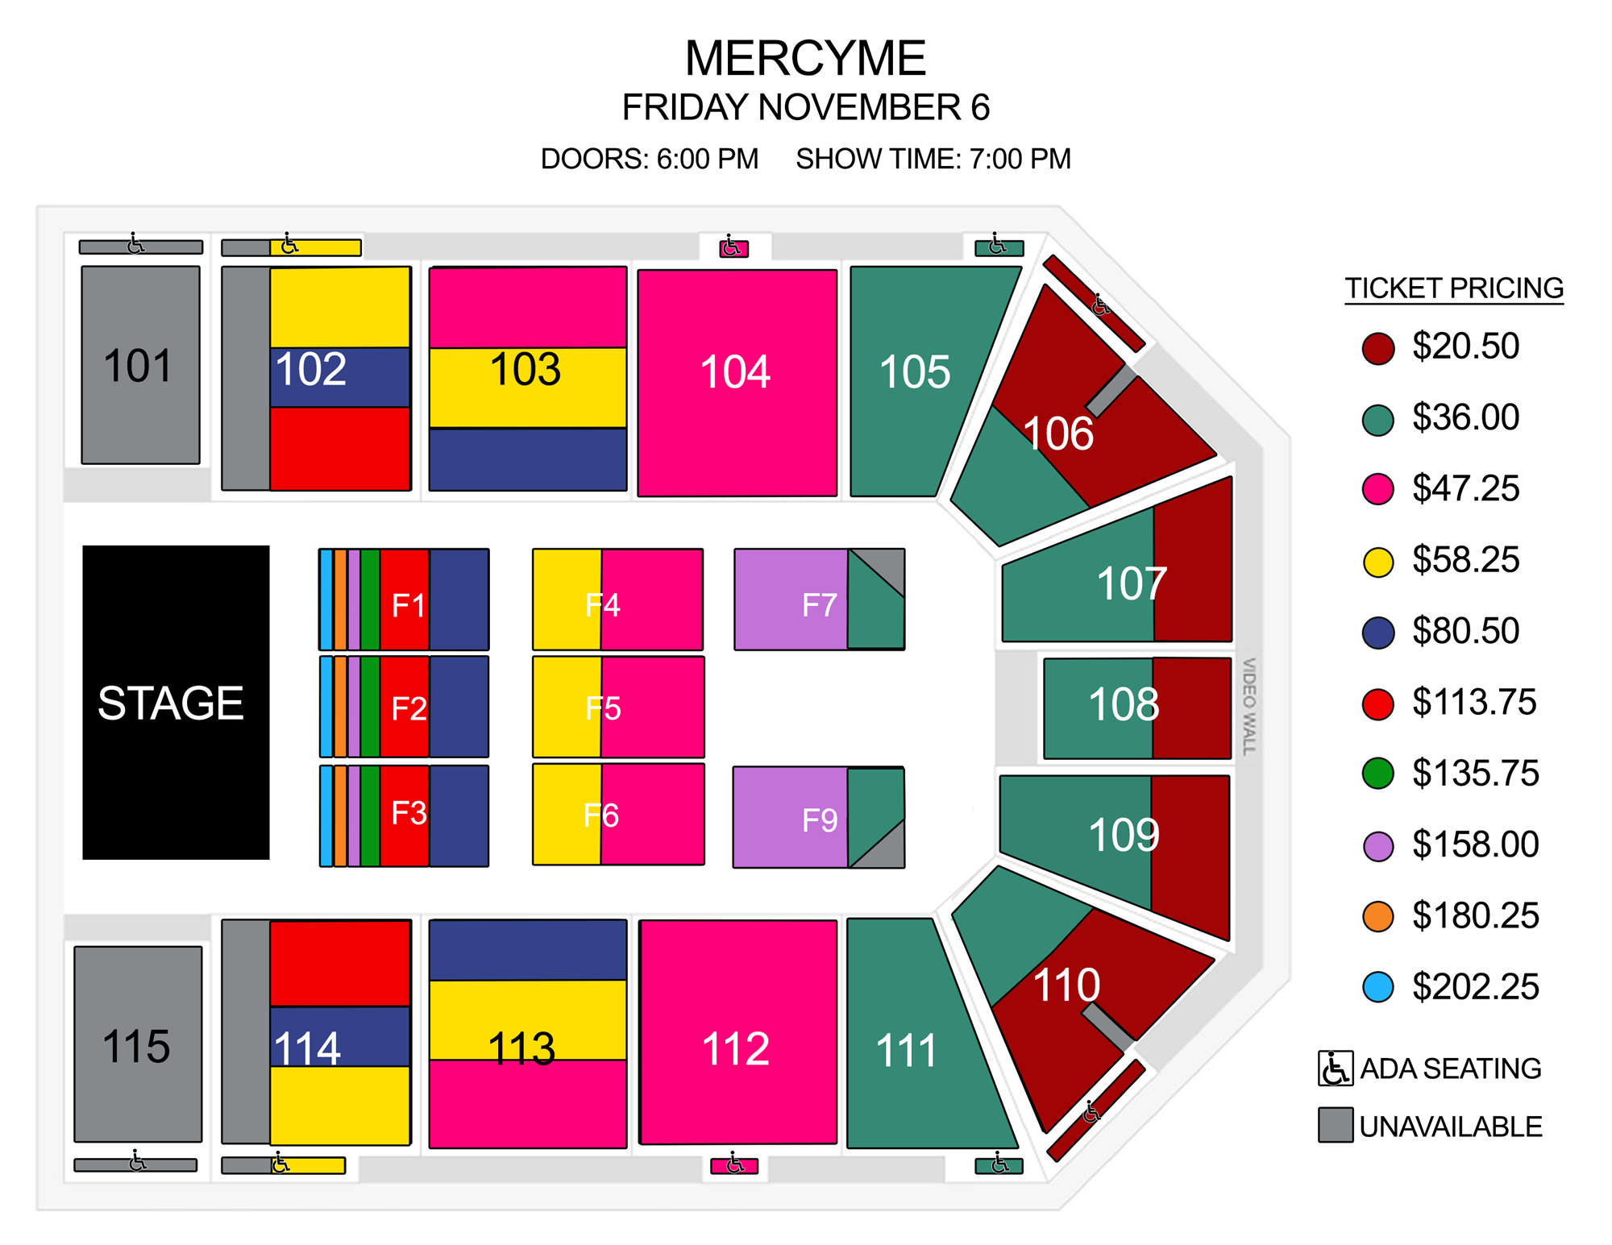
Heartland Credit union arena

Cut off: 10/30

CLUB:
$18.50
$32.50
$42.50
$52.50
$72.50
$102.50
$122.00
$142.00
$162.00
$182.00

