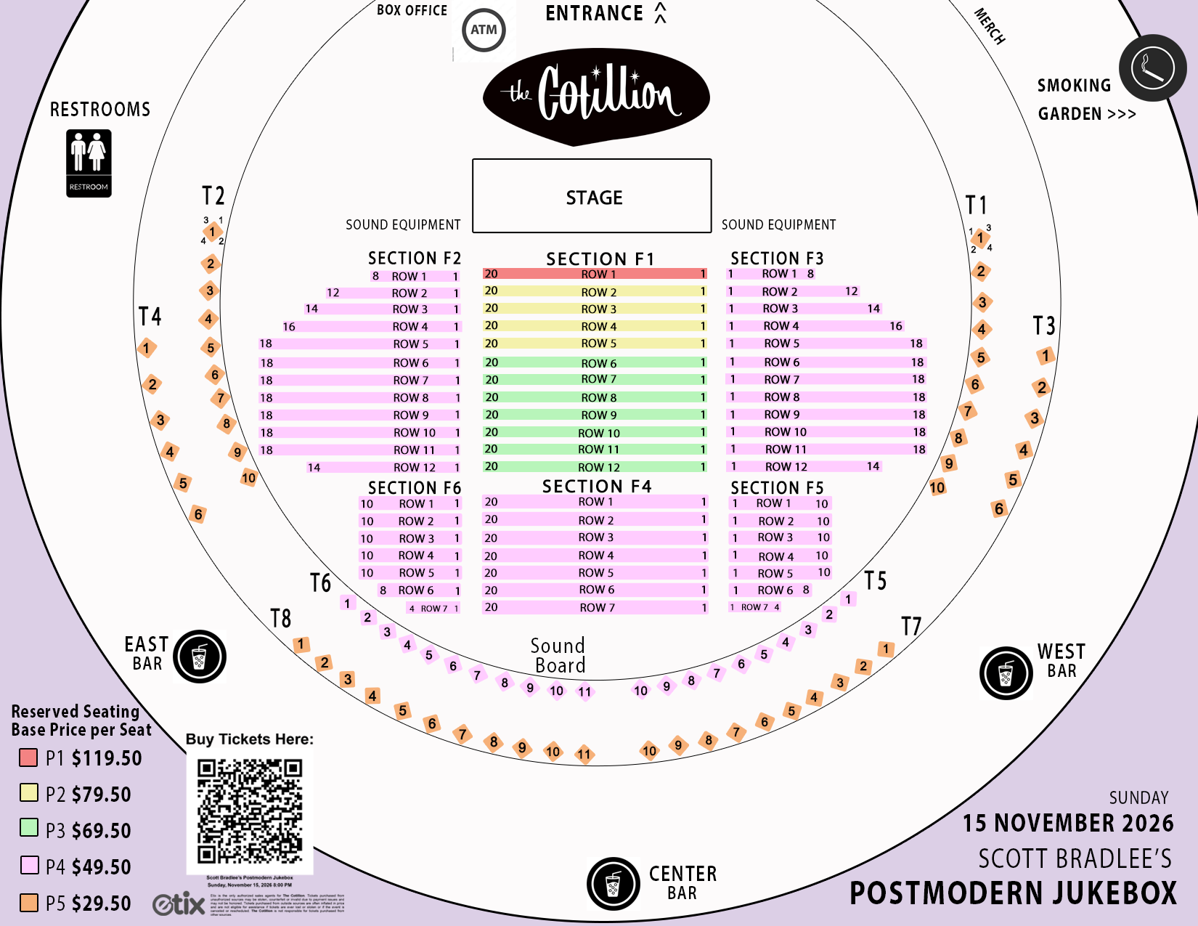

$107.50
$71.50
$62.50
$44.50
$26.50
Cut off 11/14/26

